How data is stored in computer:

I bit :

Simply 0/1 is called one bit

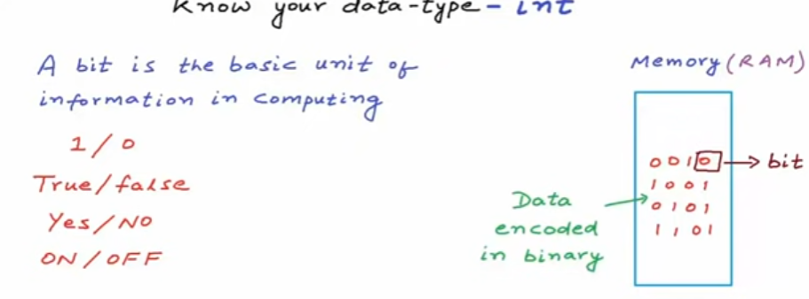

1 byte = 8bits

So int a ;

For int generally we get 4 bytes :

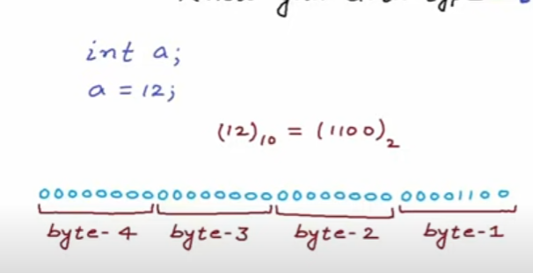

Think n = bits

For 4 bytes

1 bytes = 8 bits

4 bytes = 4\*8 = 32 bits

So we have (2^32)-1

Negative values are stored using the 2 complement,

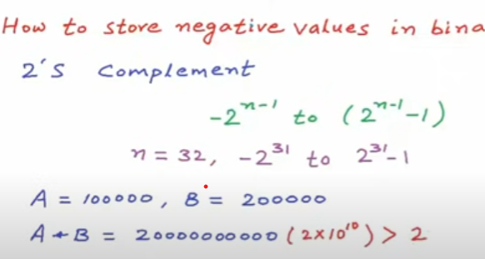

Similarly for all the datatypes the memeory representation will be like above.